PATIENT REGISTRATION FORM

Patient Name _______________________________________ M: ____. SSN #: _____-_____-______

Date of Birth: _____/_____/______ *circle: Male/ Female *circle: Married/Single/Divorced/Widow

Address: _____________________________________ City: ______________ State:____ Zip:________

Home Phone: (____)_______________ Cell: (____)______________________ Preference: Cell/Home

E-mail Address: ______________________________________________________________________
Do we have permission to send appointment reminders to your email? Yes /No

Employer: ________________________________Employer Phone Number: (____)_______________
Employer Address: ____________________________________________________________________

Primary Care Physician :_________________________________ Phone: (____)__________________

How did you hear about our Practice? ____________________________________________________

Person responsible for bill such as a parent or guardian (Complete only if different from patient)
Guarantor Name: ______________________________________ Social Security Number: _____ - _____ - _____
Relationship to Patient: self ( ) spouse ( ) or parent ( ) Date of Birth: _____/_____/________
Address: ______________________________________________________ Phone Number: __________________
Employer Name: _____________________________________ Employer Phone Number: (___) _______________
Employer Address: ____________________________________________________________________________

Who to call for an emergency:
Name: _______________________________ Address: _______________________________________
Phone: (_______) _______ - _______________Relationship: ___________________________________
_____________________________________________________________________________________________
FIRST INSURANCE INFORMATION
Plan Name: _____________________________________ I.D. Number: ___________________________
Address: _______________________________________ Group Number: _________________________
Policy Holder: ___________________________________ Effective Date: __________________________
Policy Holder’s Social Security Number: _________ - ________ - ________
Policy Holder’s Date of Birth: _____/_____/_____ Sex: M / F

SECOND INSURANCE INFORMATION
Plan Name: _____________________________________ I.D. Number: ___________________________
Address: _______________________________________ Group Number: _________________________
Policy Holder: ___________________________________ Effective Date: __________________________
Policy Holder’s Social Security Number: _________ - ________ - ________
Policy Holder’s Date of Birth: _____/_____/_____ Sex: M / F

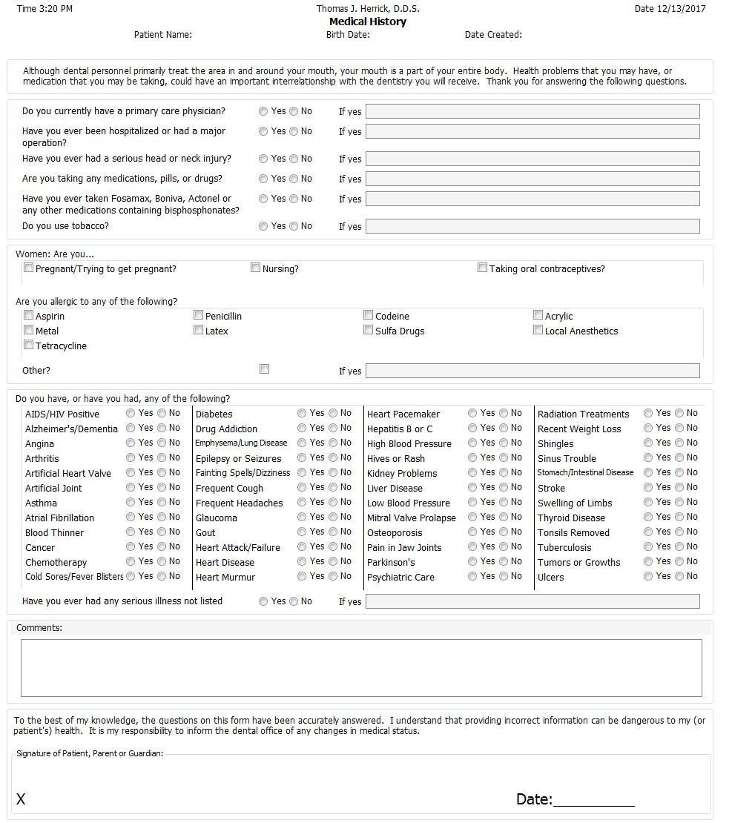

HIPAA Compliance/ Privacy Practices Consent Form
Our Notice of Privacy Practices provides information about how we may use or disclose protected health information. The notice contains a patient’s rights section describing your rights under the law. You ascertain that by your signature that you have reviewed our notice before signing this consent. The terms of the notice may change, if so, you will be notified at your next visit to update your signature/date.
You have the right to restrict how your protected health information is used and disclosed for treatment, payment or healthcare operations. We are not required to agree with this restriction, but if we do, we shall honor this agreement. The HIPAA (Health Insurance Portability and Accountability Act of 1996) law allows for the use of the information for treatment, payment or healthcare operations.
By signing this form, you consent to our use and disclosure of your protected healthcare information. You have the right to revoke this consent in writing, signed by you. However, such a revocation will not be retroactive.
By signing this form, I understand that:
- Protected health information may be disclosed or used for treatment, payment or healthcare operations.
- The practice reserves the right to change the privacy policy as allowed by law.
- The practice has the right to restrict the use of information, but the practice does not have to agree to those restrictions.
- The patient has the right to revoke this consent in writing at any time and all full disclosures will then cease.
- The practice may condition receipt of treatment upon execution of this consent.

May we leave a detailed message on your voice mail at home, cell phone or via text? YES/ NO
May we discuss your dental conditions with any member of your family? YES/ NO
If YES, please name the family members allowed:
_____________________________________________________________________________________
_____________________________________________________________________________________
By my signature below, I (print)______________________________, acknowledge that I received a copy of the Notice of Privacy Practices for Thomas J. Herrick, D.D.S.

______________________________________ __________________
Signature of patient or (representative/guardian) Date
For Office Use Only
I attempted to obtain written acknowledgement of receipt of our Notice of Privacy Practices, but acknowledgement could not be obtained because:

Individual refused to sign
Communications barriers prohibited obtaining the acknowledgement
An emergency situation prevented us from obtaining acknowledgement
Other (Please Specify)______________________________________________

_______________________________ ____________________
Employee Name Date
FINANCIAL ARRANGEMENTS
Release of Information/Financial Responsibility/Authorization for Payment

We realize that every person’s financial situation is different. For this reason, we have worked hard to provide a variety of payment options to help you receive the dental care needed to enjoy a healthy and confident smile with respect to your budget. Please read carefully and sign at the bottom.
DENTAL INSURANCE: We are happy to file the forms necessary to see that you receive the full benefits; however we can make no guarantee of coverage or what amount if any, your insurance might pay. Because an insurance policy is an agreement between you and your insurance company, you are directly responsible for your balance.
FINANCE CHARGES: Any balances remaining on your account after ninety days, may incur finance charges. This could include amounts still unpaid by your insurance.
PAYMENT OPTIONS:
Cash or Check For patients without dental insurance, we accept payment by check, cash, or care credit.
Credit Cards For your convenience we accept payment VISA, Discover or MasterCard.
Payment Plan For those who desire to make monthly payments, we have made arrangements with Care Credit to do so. There is no extra charge to you and applying is very easy. We can help you apply in our office or you can do so in the privacy of your home via the internet at www.CareCredit.com.

CANCELLED OR FAILED APPOINTMENTS:
When scheduling an appointment with our office, we will do our best to find a time that works with your busy schedule and we ask that you give us the same respect in return. Our office charges $50 or 10% of the treatment cost for all appointments that are failed or cancelled without 48 hours advance notice. This applies to cancellations left on our answering machine and or texts.

I understand that I am responsible for all charges incurred and that my estimated co-payment is due at the time of service. I agree to pay any finance charges, collection fees and/or attorney expenses should it be necessary to refer this account to collections and I understand that any unpaid accounts will be reported to credit bureaus.

I hereby authorize the office of Thomas J. Herrick, D.D.S. to affix my name to any and all claims or documents as related to any health benefits due to my dependents or myself. I authorize the release of any medical information necessary to process my claims. I hereby authorize payment of dental benefits otherwise payable to me, directly to Dr. Herrick’s office. I agree to be responsible for all charges for dental services and materials not paid by my dental benefit plan, unless the treating dentist has a contractual agreement with my plan prohibiting all or a portion of such charges. To the extent permitted under applicable law, I authorize the release of any information relating to the claim.

*A photocopy of this document may act as an original.

__________________________________________________
Printed Patient Name or representative

__________________________________________________
Signature of patient or representative

DATE: ________________________

